**Conversion of SVG to STL Instruction**

**Recommended Option:** [**https://imagetostl.com/convert/file/svg/to/stl**](https://imagetostl.com/convert/file/svg/to/stl)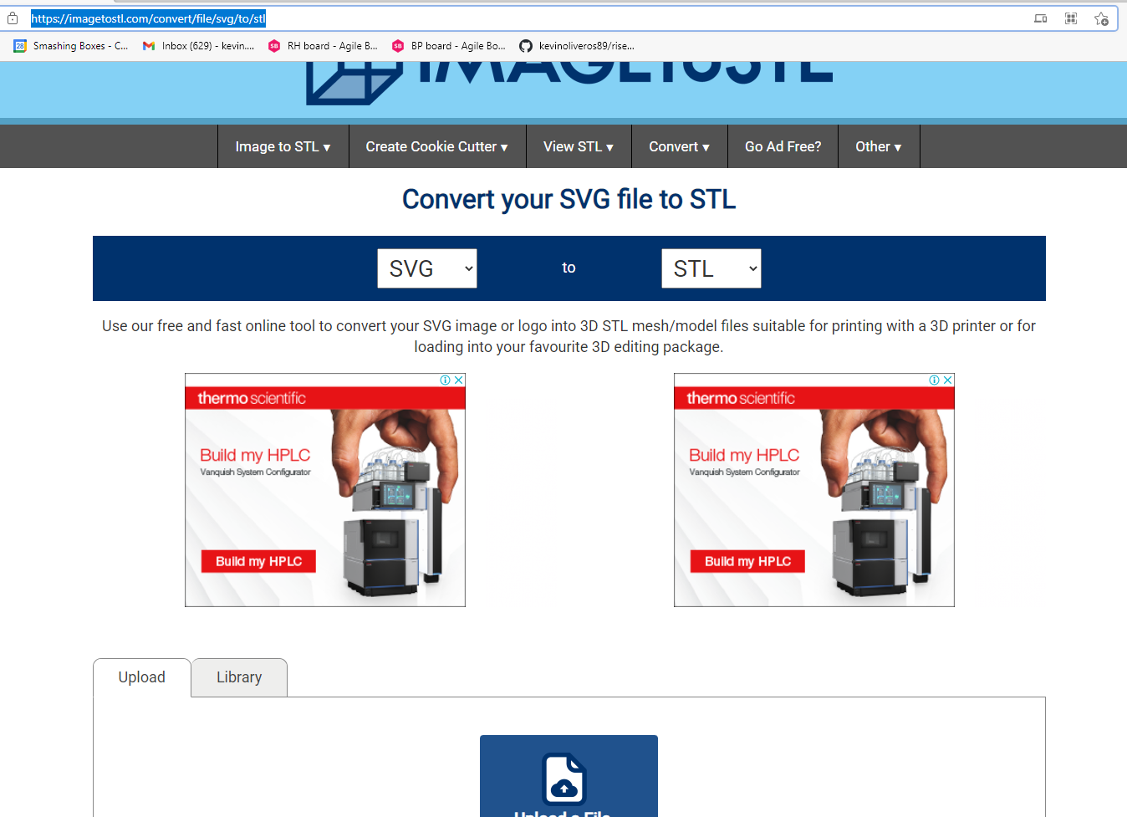

**Option 1.** Using Tinkercard site. [**https://www.tinkercad.com/**](https://www.tinkercad.com/)

1. With just importing the SVG file to the site. Then you can add additional designs s you like. Or download the format to STL  
   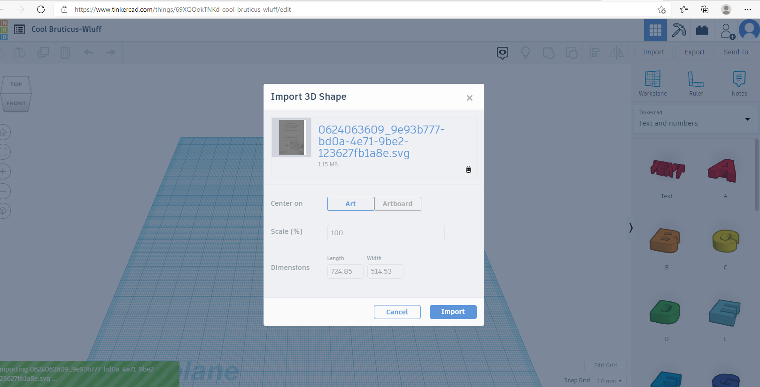  
     
   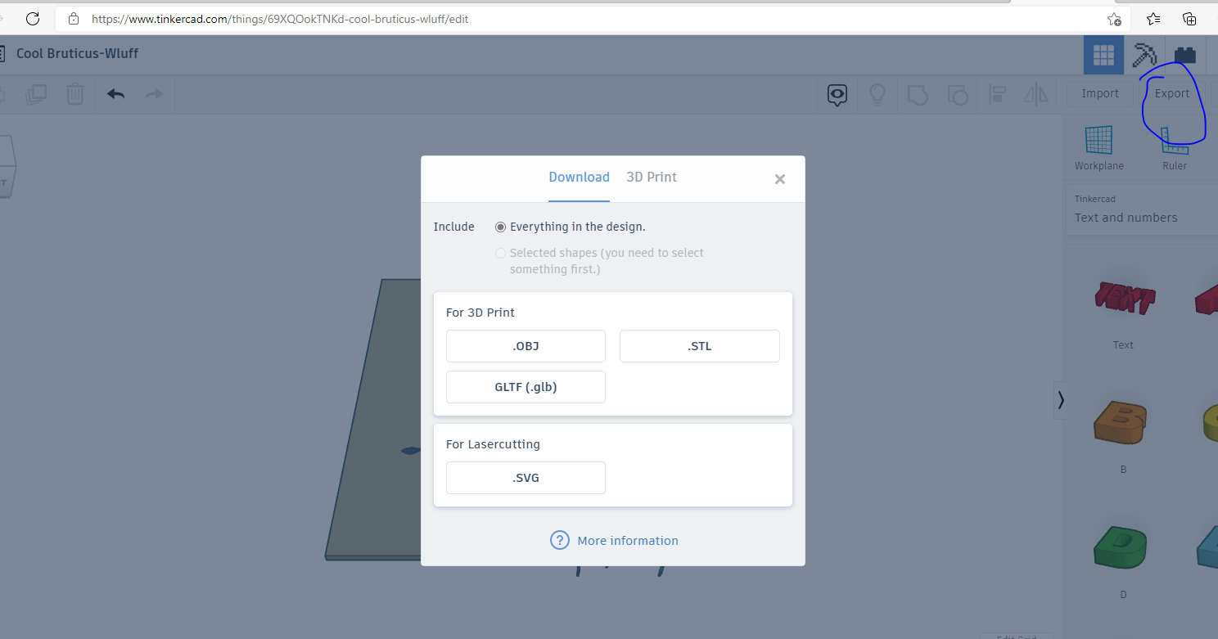

**Option 2. Using RCall Converter.** [**https://rawgit.com/r,/svg-to-stl/master/SVGtoSTL.html**](https://rawgit.com/r,/svg-to-stl/master/SVGtoSTL.html)

1. **Simple interaction by uploading the SVG and Downdload the STL  
    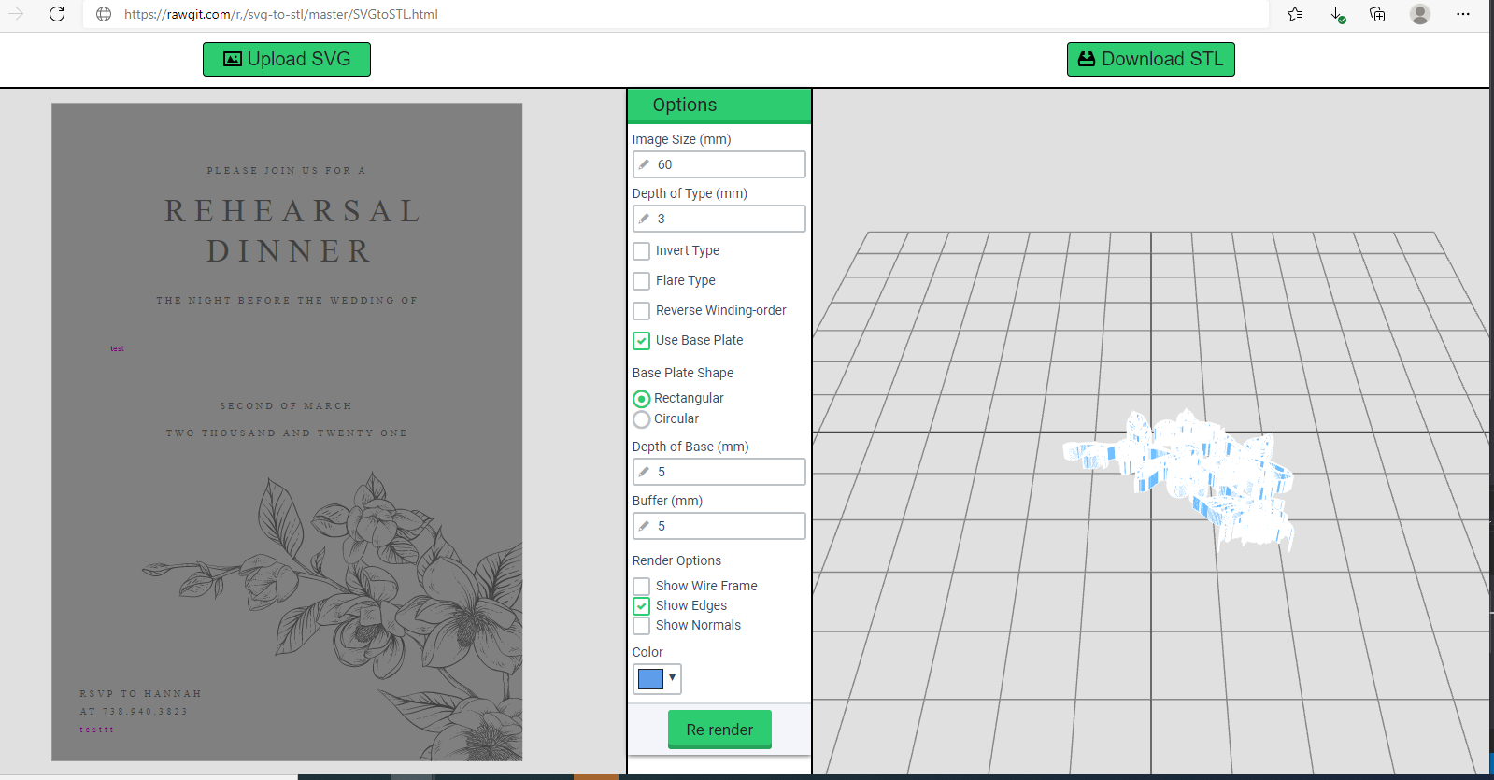**

**Option 3. AnyConvert From SVG to STL.** [**https://anyconv.com/svg-to-stl-converter/**](https://anyconv.com/svg-to-stl-converter/)



**Option 4. Using Wings3D software.** [**http://www.wings3d.com/**](http://www.wings3d.com/) 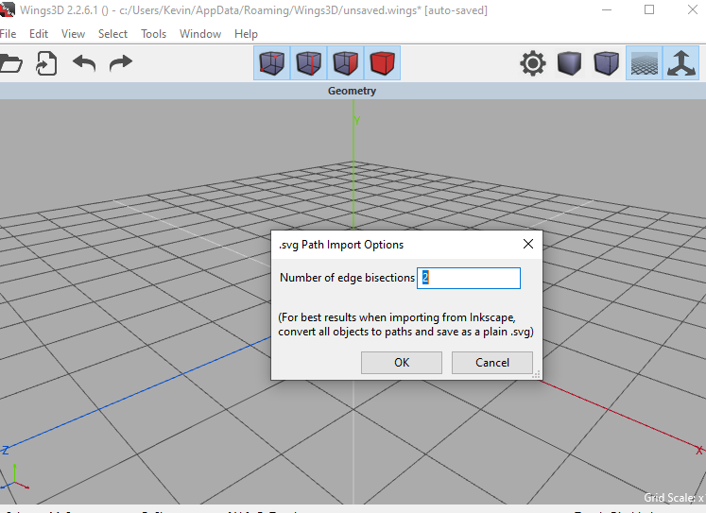

**Option 5. Using FreeCad Software.** [**https://www.freecadweb.org/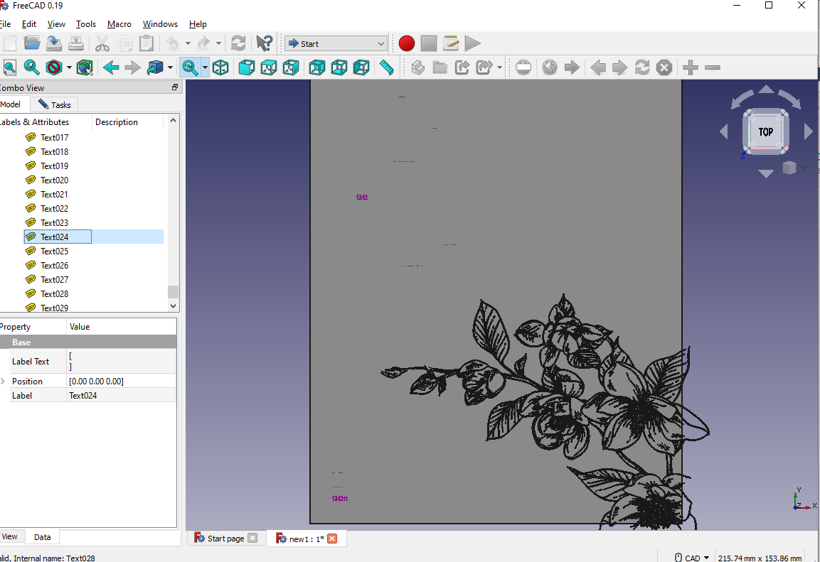**](https://www.freecadweb.org/*)

**Option 6. Using Axdea software.** [**http://www.innovacia.com.my/axdea/index.html#axdea**](http://www.innovacia.com.my/axdea/index.html#axdea) **